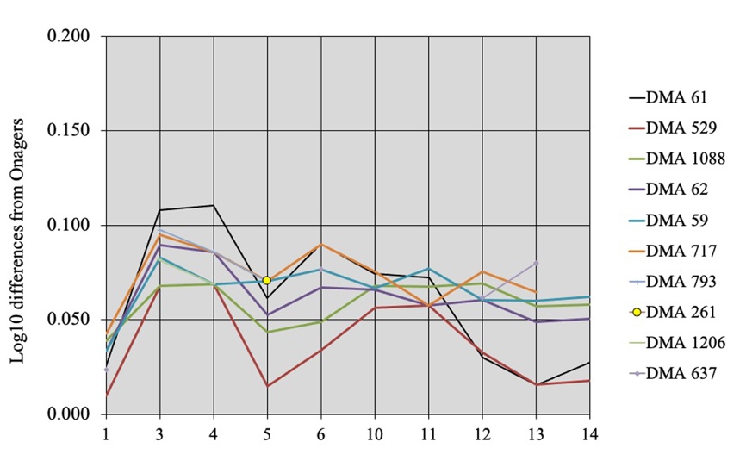

Figure S20. Simpson's diagrams of Dmanisi slender metacarpals. 1: Maximal length. 3: Breadth at the middle of the diaphysis. 4: Depth of the diaphysis at the same level. 5: Proximal breadth. 6: Proximal depth. 10: Distal supra-articular breadth. 11: Distal articular breadth. 12: Depth of the sagittal crest. 13: Least depth of the medial condyle. 14: Greatest depth of the medial condyle.

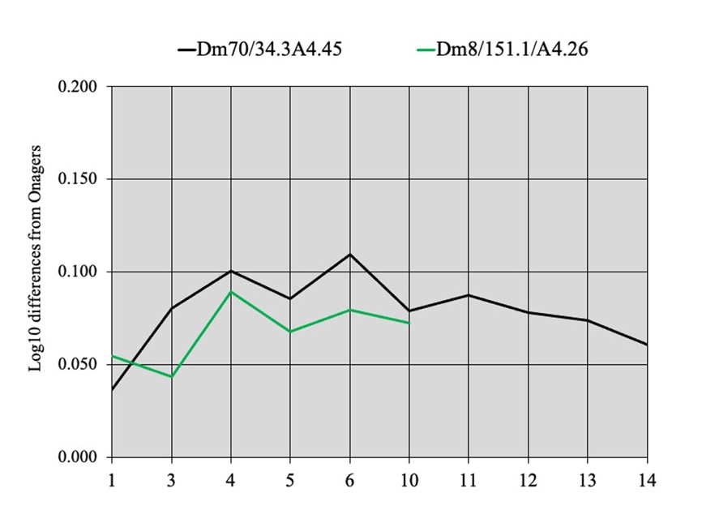

Figure S21. Simpson's diagrams of Dmanisi Dm70/34.3A4.45 and Dm8/151.1/A4.26 (probably juvenile) metacarpals.1: Maximal length. 3: Breadth at the middle of the diaphysis. 4: Depth of the diaphysis at the same level. 5: Proximal breadth. 6: Proximal depth. 10: Distal supra-articular breadth. 11: Distal articular breadth. 12: Depth of the sagittal crest. 13: Least depth of the medial condyle. 14: Greatest depth of the medial condyle.

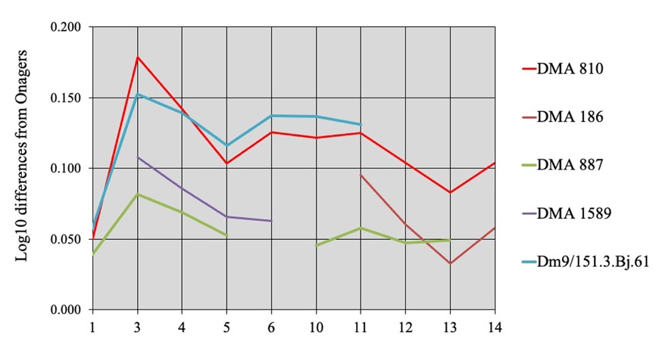

Figure S22. Simpson's diagrams of Dmanisi metacarpals from Layers II, III, and Stratum B. 1: Maximal length. 3: Breadth at the middle of the diaphysis. 4: Depth of the diaphysis at the same level. 5: Proximal breadth. 6: Proximal depth. 10: Distal supra-articular breadth. 11: Distal articular breadth. 12: Depth of the sagittal crest. 13: Least depth of the medial condyle. 14: Greatest depth of the medial condyle.